FINCORE
Home path
/equity_fe/EQPROD/FrontEnd/FinacleApps/finbranch.war/custom/

JSP DEPLOYMENTS
GROUP
/equity_fe/EQPROD/FrontEnd/FinacleApps/finbranch.war/custom/jsp
KE JSP
SS JSP
And so forth

JAVA SCRIPT DEPLOYMENT
/equity_fe/EQPROD/FrontEnd/FinacleApps/finbranch.war/custom/javascripts

MENU WISE

ENTITY WISE
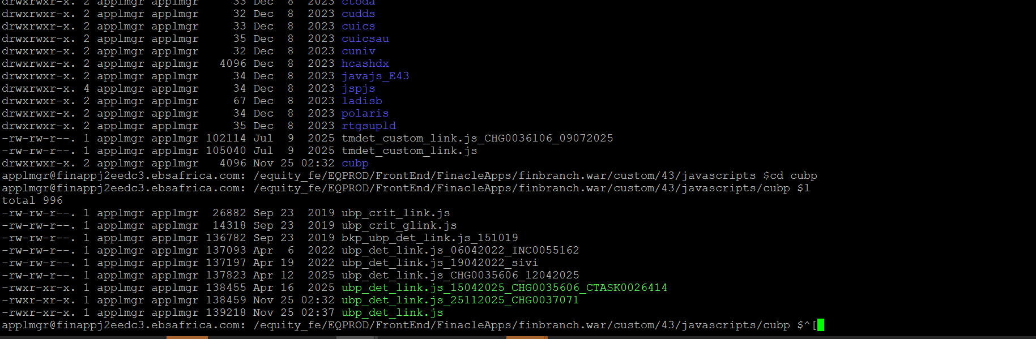

GROUP XML DEPLOYMENT

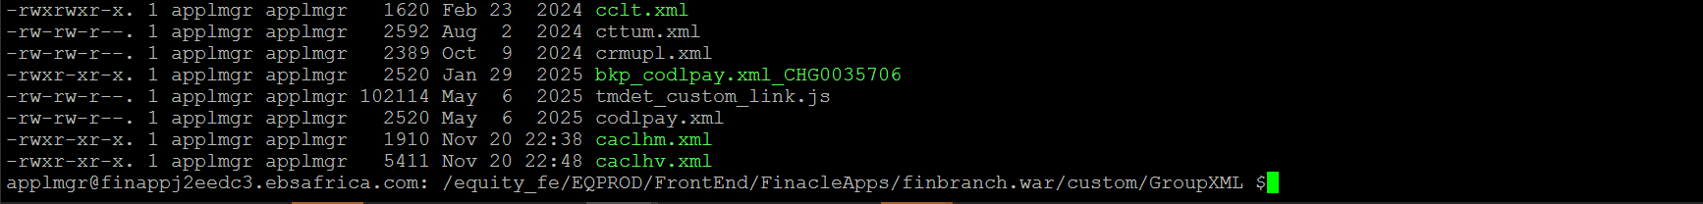

CRM
Home path
/equity_fe/EQPROD/FrontEnd/FinacleApps/FinacleCRM.ear/FinacleCRM.war/Customization

